**CONCLUSIONS/RESULTS**

With the near perfect bootstrap values and posterior probabilities, the following conclusions can be made with high confidence:

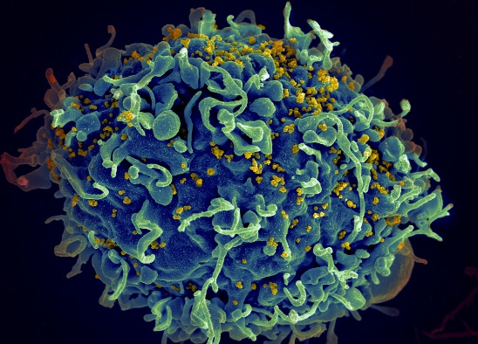**Production of Trees With A Specific Region and High Bootstrap/Posterior Probability.** The tree itself is a conclusion – almost no trees regarding HIV-1 and HIV-2 produced to date have had such incredible bootstrap values or posterior probabilities, which is impressive to find after almost 50 years of research in the field. And certainly no tree with as specific a focus as this (a regional focus on West Africa and strains of HIV-1 and HIV-2 prevalent in the area) has been published with such high values, adding to the value of the produced trees.

HIV Infecting CD4

**Identification and Support of General Theories Found in Other Regions.** Major general theories found in other regions are also shown on the tree, which have been discovered over the years. These patterns include: HIV-1 with SIVcpz, HIV-2 with SIVsmm, a large split between the two and that major subtypes of the viruses split at different points.

**Identification of Correlation Between HIV-1 Type O and Gorilla SIV.** A very new theory, only a couple years old, is the idea that HIV-1 Type O, or the outlier group, in fact came from SIV from gorillas and not chimpanzees. My trees provide strong support for this idea, showing a clear relationship between the two.

**Support for HIV-2 Types A and B Being From One Independent Transmission**. The leading theory regarding the subtypes A and B of HIV-2 is that they came from separate sooty mangabey to human transmissions. However, my trees provide strong evidence for the alternative idea that they in fact came from one transmission and then branched off from there, an idea that completely changes the evolutionary ideas behind the two subtypes of HIV-2.